**Circuit and System-I Lab**

**Project Report**



**Spring 2022**

Submitted by:

Suleman Shah (**21PWCSE1983)**

Shahzad Bangash (**21PWCSE1980)**

Ali Asghar (**21PWCSE2059)**

“On my honor, as student of University of Engineering and Technology, I have neither given nor received unauthorized assistance on this academic work.”

Submitted to:

**Engr. Faiz Ullah**

28 July, 2022

Department of Computer Systems Engineering

**BLIND WALKING SMART STICK**

**ABSTRACT:**

Blind Walking Smart Stick helps the blind and visually impaired persons. In this modern era of technology, almost every person is at risk of losing his eye sight. The number of blind persons is increasing day by day. To solve this issue, we have come up with the idea of Blind Walking Smart Stick. It is an effort to lessen the issues faced by blind persons during walk. This project makes use of Arduino and Ultrasonic sensor for detecting obstacles in the path of blind person. The signal is received by Ultrasonic Sensor in a certain range and then the output is shown in the beep of a buzzer. The whole above logic is implemented in a stick.

**INTRODUCTION:**

Almost 39 million people are blind according to the recent WHO Report. These blind people are totally dependent on others as they can’t walk alone. This is the reason why we have designed the Blind Walking Smart Stick device which will help blind people to walk with ease independently. First of all, let’s explain the main components of this project.

**COMPONENTS USED:**

1. Arduino UNO Board
2. HC-SR04 Ultrasonic Sensor
3. Buzzer
4. 9 Volt Battery
5. Stick
6. Connecting Wires

**CIRCUIT SKETCH:**

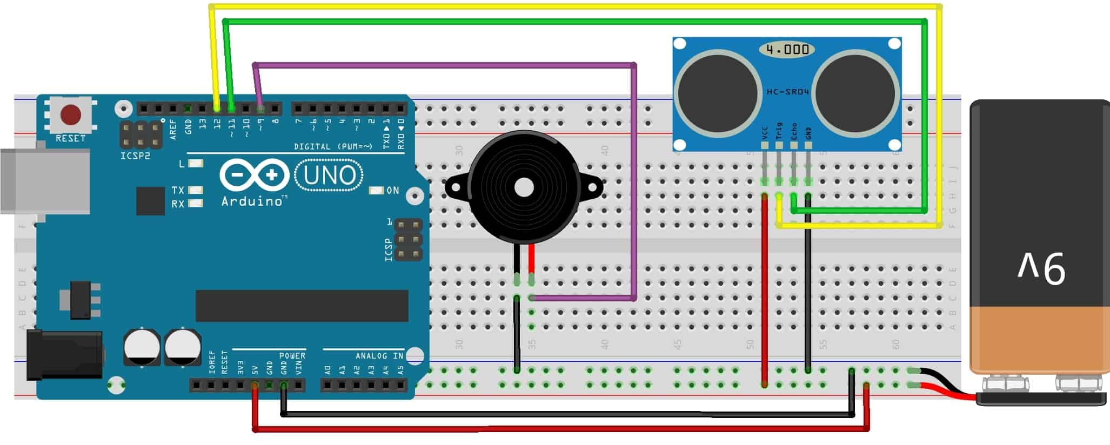

**DESCRIPTION OF EACH COMPONENT:**

1. **Arduino UNO:**

Arduino is a microcontroller used to control and integrate electronic components with each other. It is used in many electronic projects. The Arduino consists of Analog and Digital I/O pins and some other pins as shown in the figure.

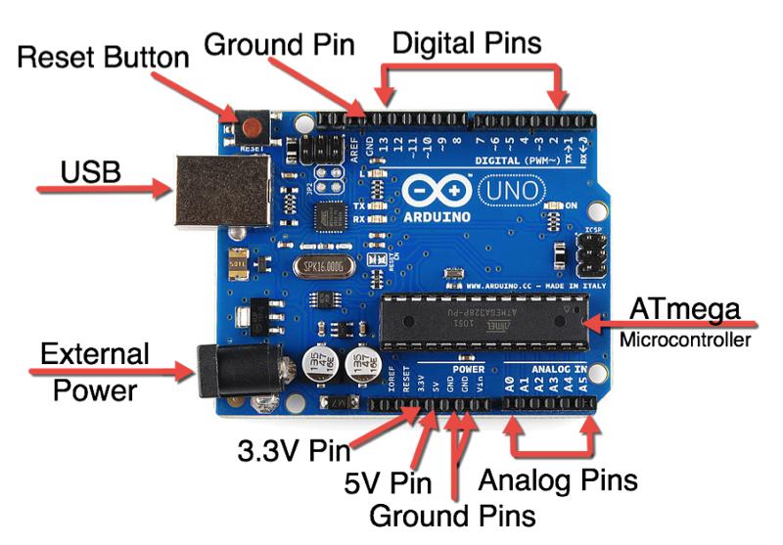

1. **Buzzer:**

Below figure shows an active buzzer which means it directly produces sound as soon as it gets the required DC voltage mostly 3.5V – 5.0V.

It is used in timers, alarm devices, computers, etc.

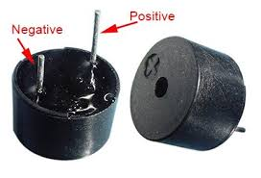

1. **HC SR04 ULTRASONIC SENSOR:**

HC SRO4 ultrasonic sensor consist of 2 pins, trig and echo, are the pins required to generate ultrasonic waves.

This sensor’s working principle is that when the trig pin becomes high the transmitter module generate and transmit the ultrasonic waves. Simultaneously the echo pin becomes high too. Now when the waves reflect back by striking an object in front of it, the receiver module receives the reflected waves and at the same time, the echo pin becomes low. Hence the time interval at which the echo pin remained high is the total time taken by the waves.

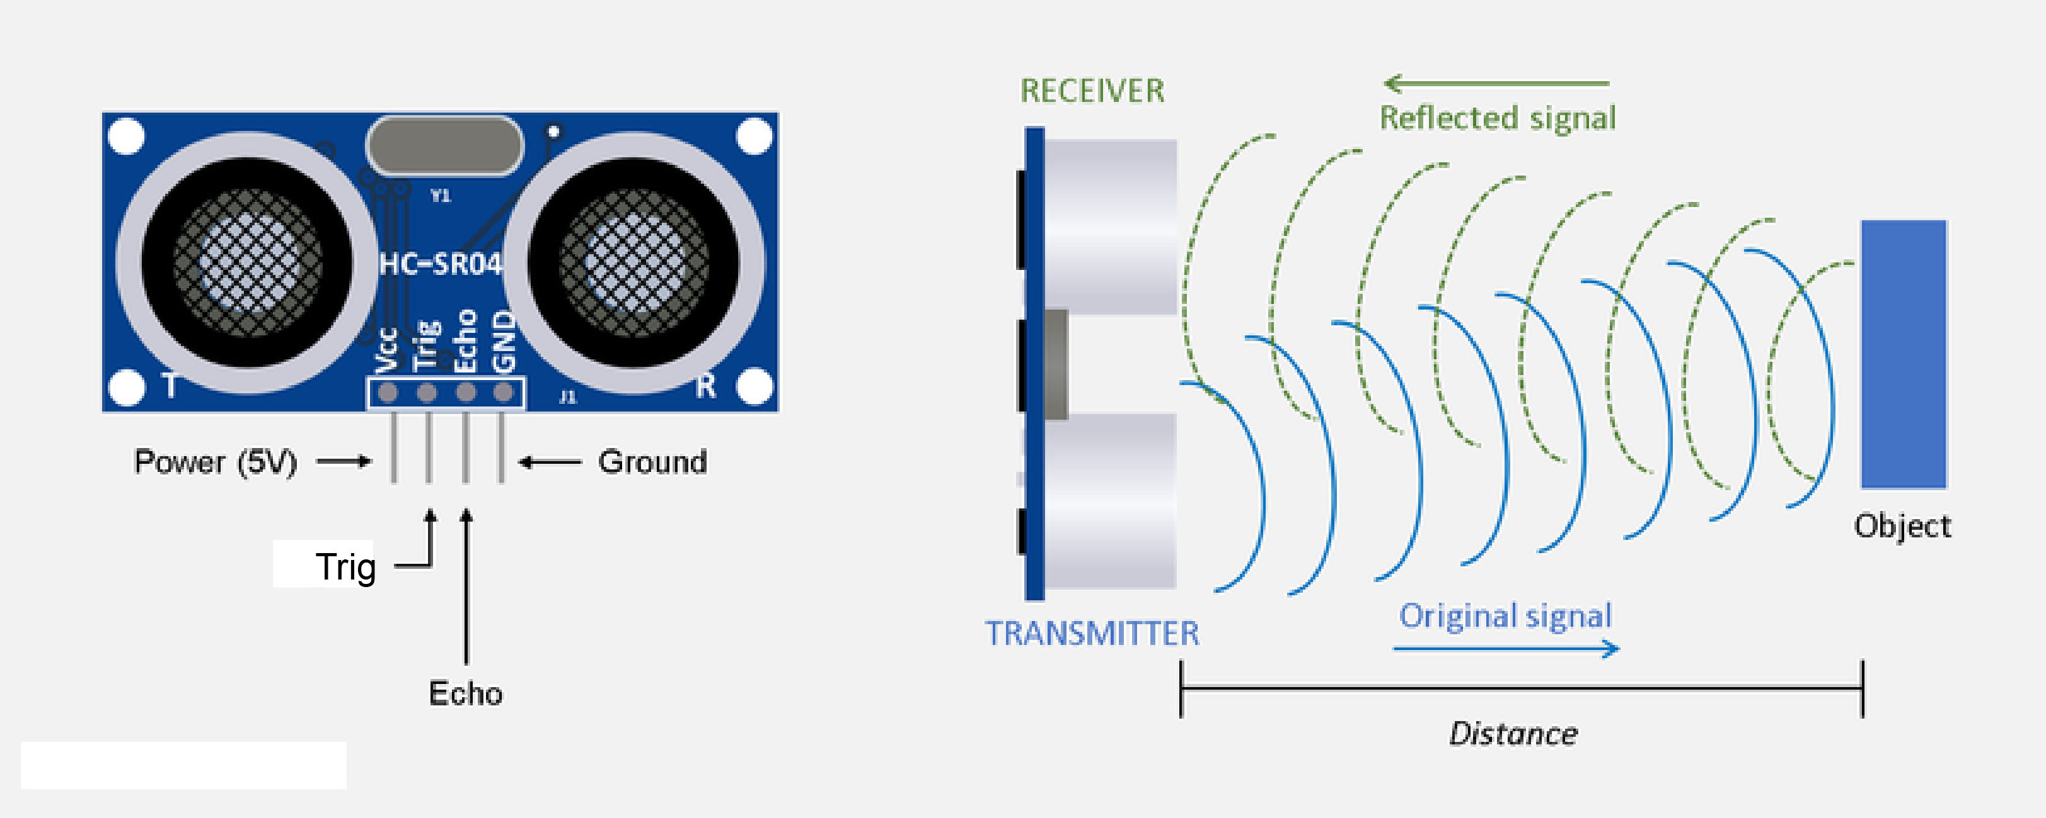

Other components are common, so there’s no particular need to describe them.

**CIRCUIT CONNECTIONS:**

1. Vcc pin of HC-SR04 is connected to 5 volt pin of Arduino
2. Trigger pin of HC-SR04 is connected to D12 pin of Arduino
3. Echo pin of HC-SR04 is connected to D11 pin of Arduino
4. The ground of HC-SR04 is connected to the GND pin of Arduino.
5. A buzzer is connected between the D4 pin of Arduino and the GND pin.

**CIRCUIT & WORKING:**

The main objective of this project is to help blind people to walk with ease and to be warned whenever their walking path is obstructed with obstacles. As a warning signal via buzzer, whose frequency of beep changes according to the distance of the object. The closer the distance of obstruction, the more will be the buzzer beep frequency.

The main component used for this device is the Ultrasonic Sensor HC-SR04. The ultrasonic sensor transmits a high frequency sound pulse and then calculates the time to receive the signal of the sound echo to reflect back. HC-SR04 has a transmitter & receiver surface. One of them acts as the transmitter and transmits the ultrasonic waves. The other one acts as a receiver and receives the echoed sound signal. The sensor is calibrated according to the speed of the sound in air. The speed of sound is 341 meters per second in the air, and the distance between the sensor and object is equal to time multiplied by the speed of sound divided by two.

**Distance = (Time * Speed Of Sound) ÷ 2**

After the distance measurement, Arduino makes a beep format using a buzzer, when the distance is high, the frequency of beep is decreased and beep frequency is increased when the distance is low.

**FLOW CHART OF ARDUINO CODE:**

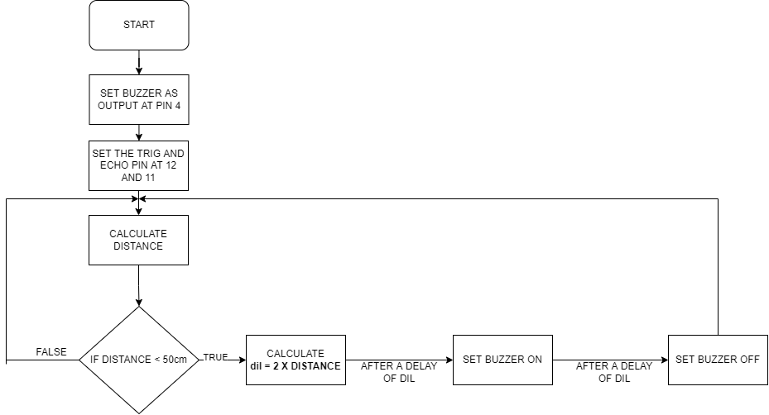

**SUMMARY:**

Using Arduino UNO and HC-SRO4 Ultrasonic Sensor, we can make a blind walking smart stick by passing output to a buzzer. A code is written in c language to run Arduino according to our instructions. This code is uploaded to Arduino using Arduino cable and then circuit connections are made to make the required smart stick possible. HC-SRO4 Ultrasonic Sensor detects the obstacles in the path and informs the user of the smart stick by beep through buzzer. The frequency of beep changes according to the distance from the obstacle.

**CONCLUSION:**

We can use Ultrasonic Sensor (in association with Arduino) for smart object detections. This idea can be utilized in many ways for the welfare of Human Society. Blind Walking Smart Stick is just a small step in this movement for welfare of Human Society. There’s still a lot to achieve and great ideas are yet to come.

**REFERENCES:**

<https://www.freepptbackgrounds.net/business-finance/light-blue-lines-powerpoint-backgrounds>

<https://www.cleanpng.com/png-arduino-uno-atmega328-single-board-microcontroller-2942625/>

<https://www.typewolf.com/austin>

<https://www.flaticon.com/premium-icon/motherboard_5921800>

<https://www.flaticon.com/free-icon/buzzer_5387095>

<https://how2electronics.com/blind-walking-stick-arduino-ultrasonic-sensor/>

<https://www.flaticon.com/free-icons/electronic>